TASK 1

BASIC OPERATION ON POWERBI

STEP 1: OPEN THE POWERBI APP AND SELECT THE BLANK REPORT

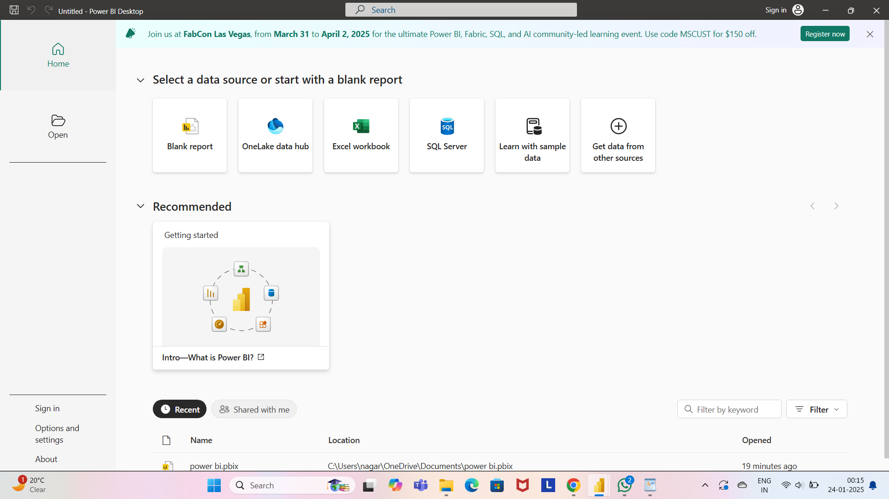

CLICK ON BLANK REPORT

STEP 2:OPEN POWERBI AND THEN RETRIVE THE DATA FROM THE BY USING THE GET DATA BUTTON

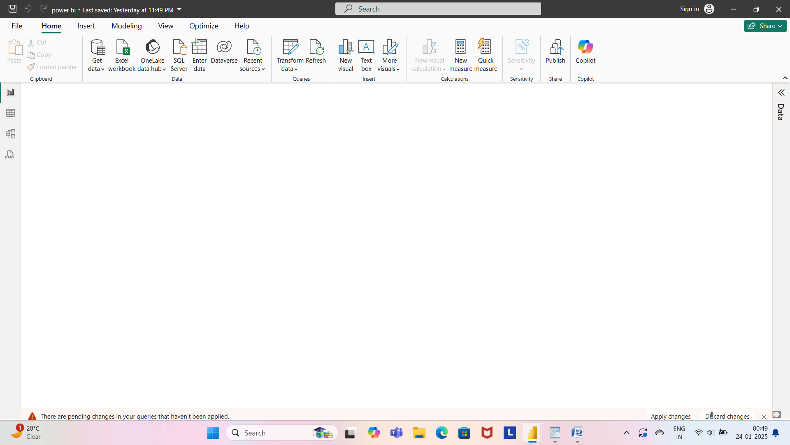

CLICK ON GET DATA

Step 3: AFTER CLICKING THE GET DATA OPTION SELECT THE TEXT/CSV FROMAT TYPE FROM THE GIVEN DATA SOURCES OPTION TO RETRIEVE THE CSV FILE FROM LOCAL STORAGE. CLICK

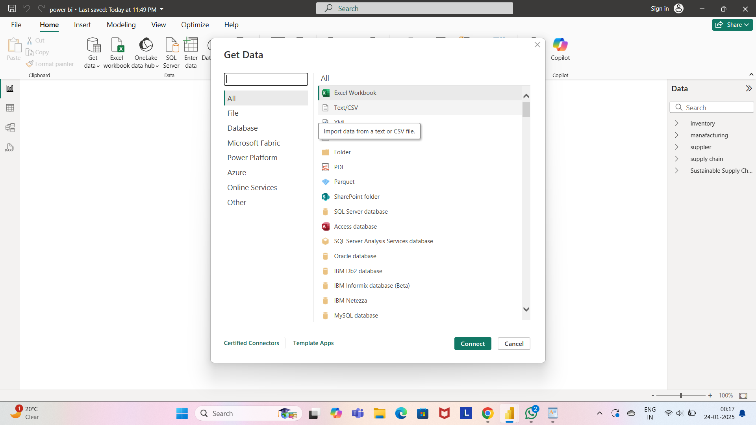

STEP 4: AFTER SELECTING THE TEST/CSS CHOOSE THE SUSTAINABLE FILE

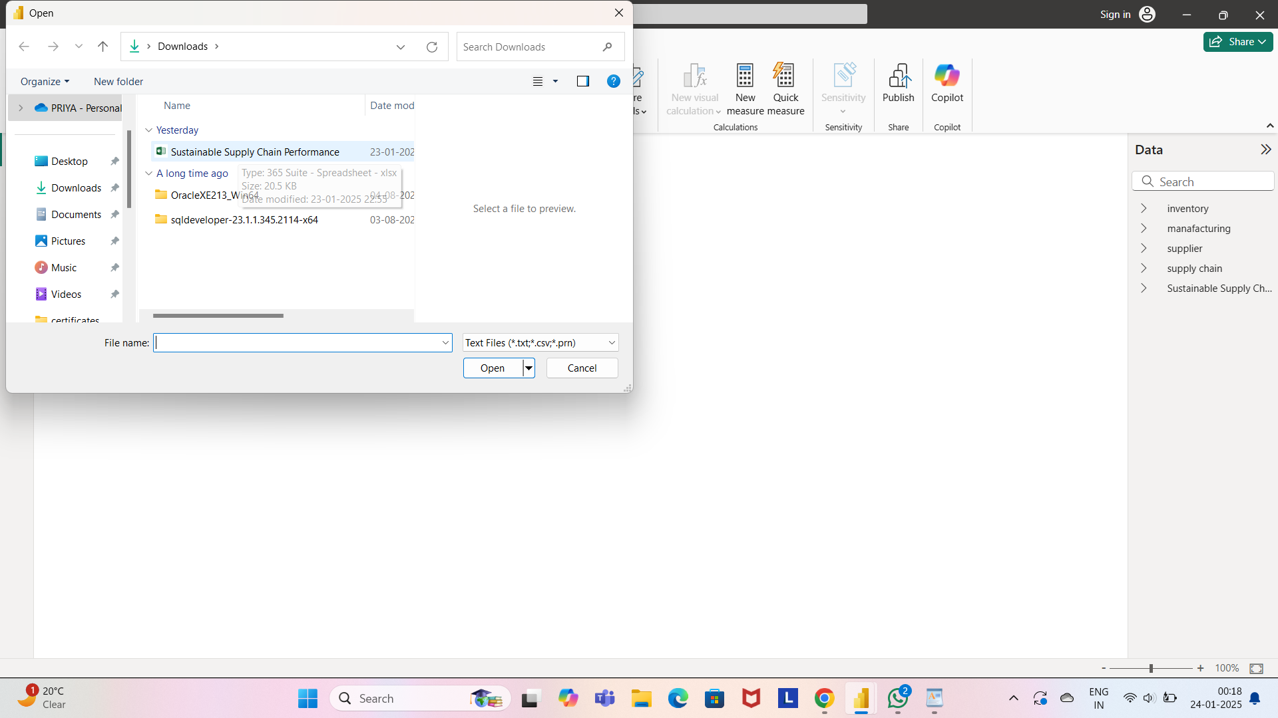

STEP 5: THEN SELECT THE FILE FROM THE LOCAL PC STORAGE AND OPEN IT.

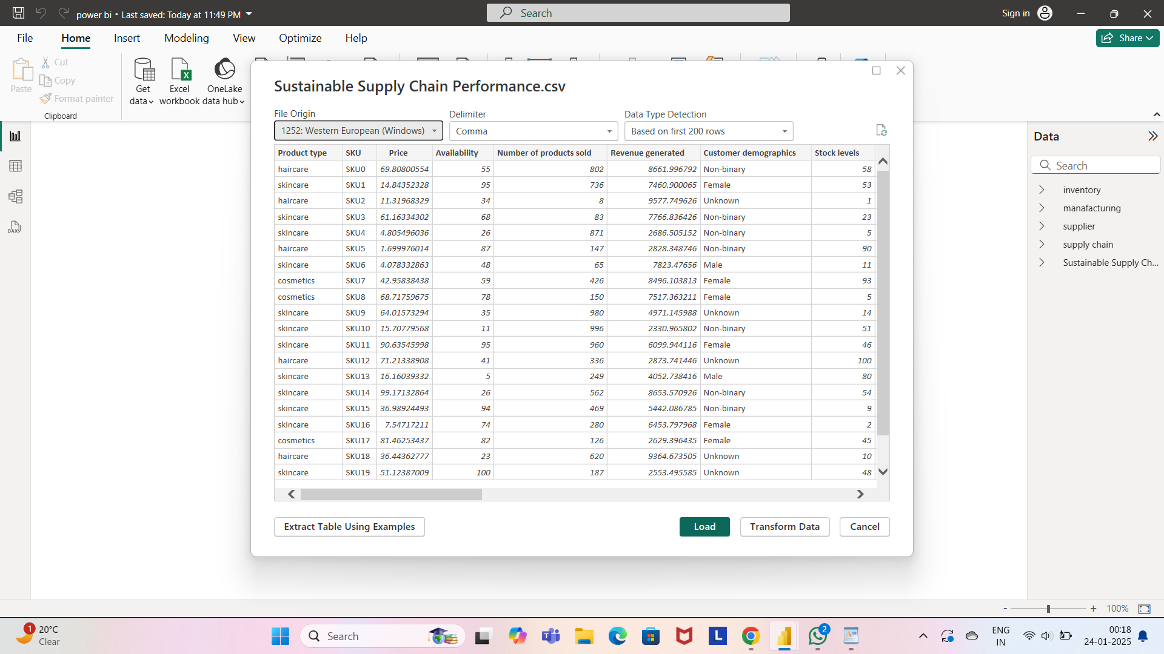

CLICK ON LOAD

STEP 6: AFTER OPENING THE CSV FILE, WE WILL BE CLICKING ON THE TRANSFORM DATA TO CLEAN THE DATA BY REMOVING VARIOUS DATA ERRORS SUCH AS MISSING VALUES AND DUPLICATES OR WE CAN DELETE UNNECESSARY ROWS OR COLUMNS TO TRANSFORM THE DATA SET.

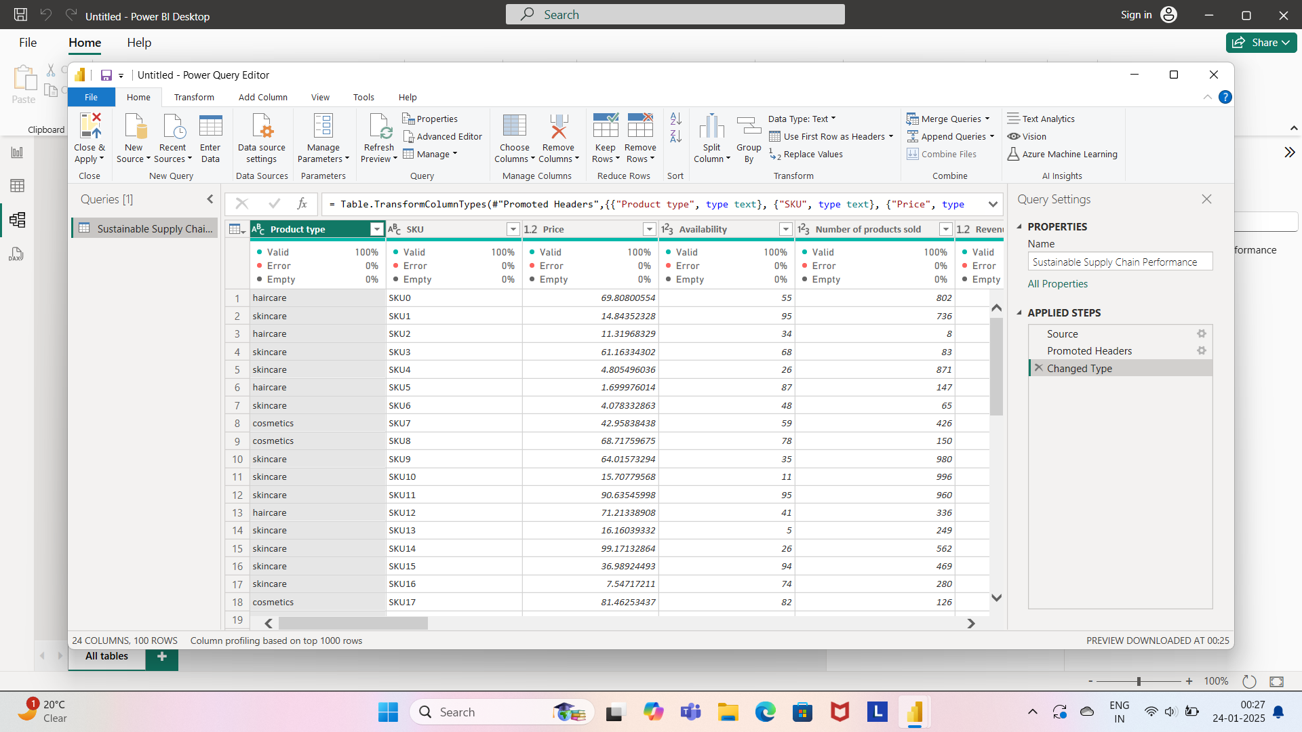

STEP 7: WE CAN REMOVE THE BLANK ROWS BY CHOOSING THE REMOVE BLANK ROW OPTION



STEP 8: WE CAN DELETE THE ROW ID SECTION COMPLETELY TO REMOVE THE WHOLE ROW.

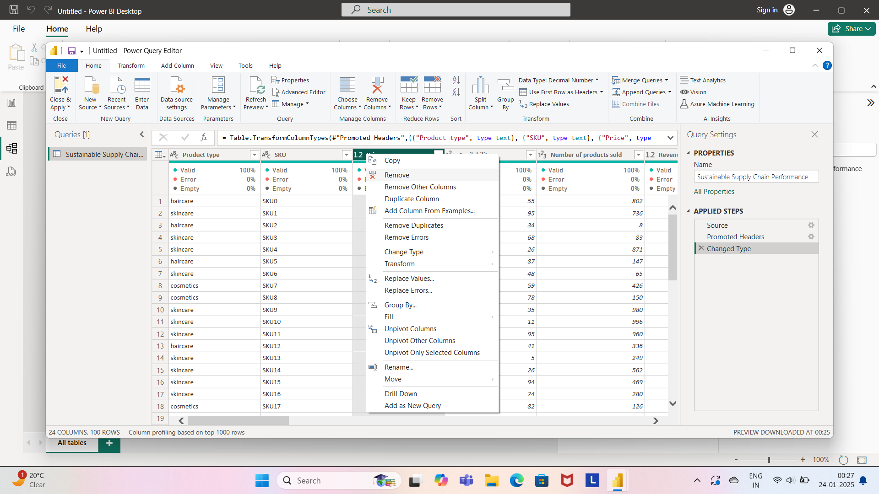

STEP 9: ONCE THE DATA TRANSFORMATION TASK IS DONE THEN CLICK ON THE CLOSE AND APPLY BUTTON TO LOAD THE DATA FOR FURTHER PROGRESSING

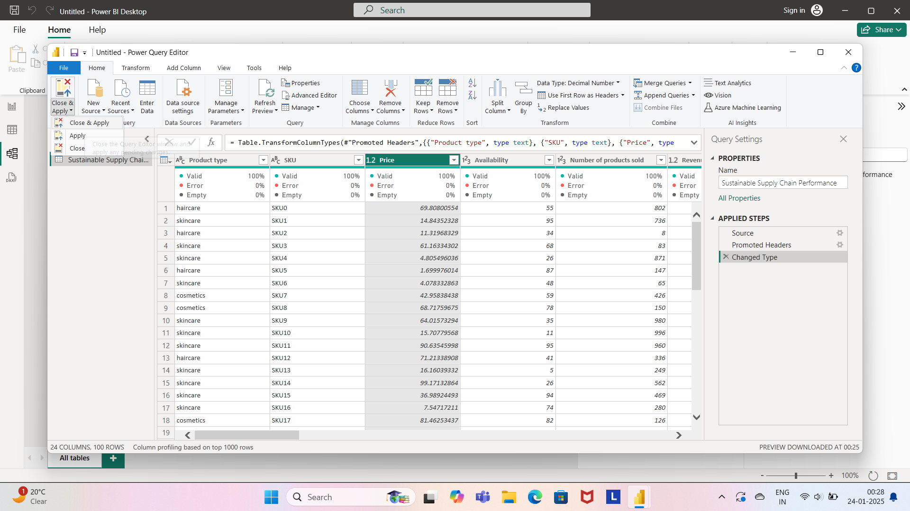

STEP 10: AFTER LOADING THE DATA GO TO THE REPORT VIEW AND VISUALIZE THE DATASET INTO DESIRED FORMAT.

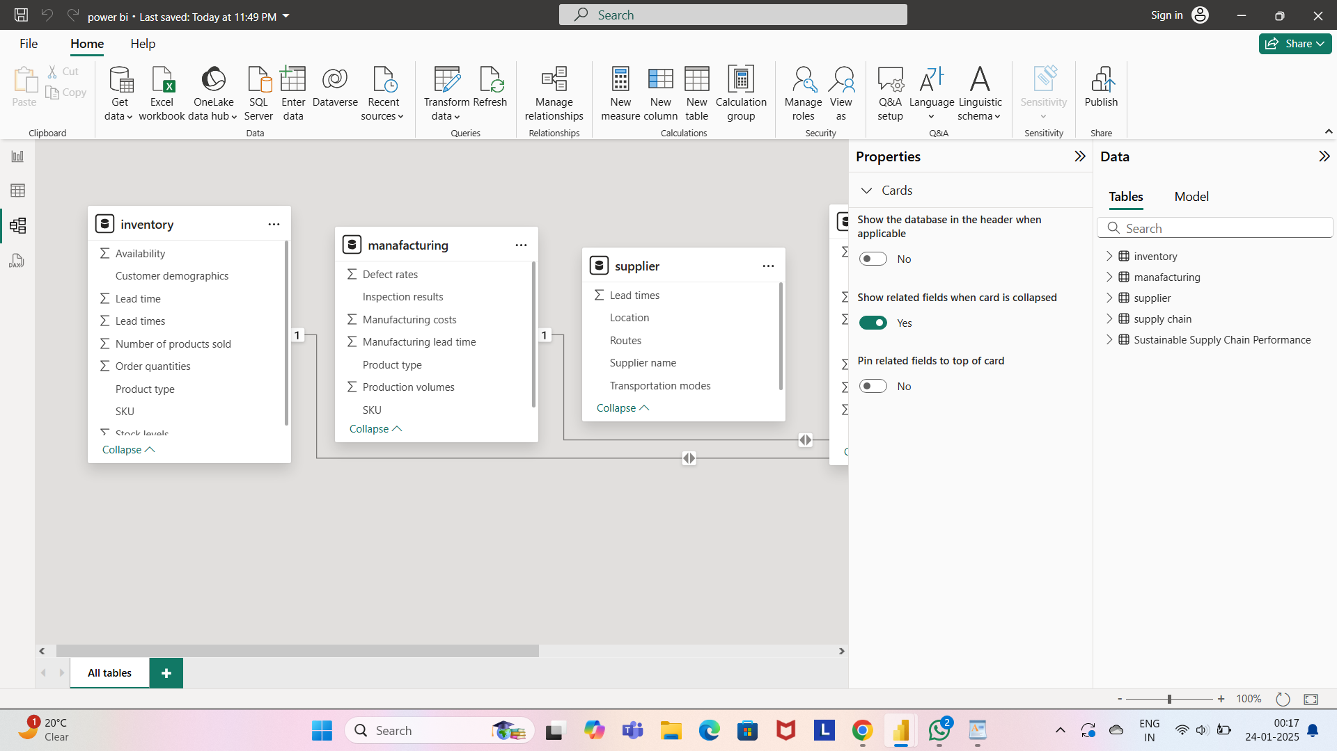

HENCE, OUR BASIC OPERATION IS COMPLETE.